Metric QA Agent v2 (former Swivel Sync) Requirements Checklist

Overview

Objective: Empower non-technical users to compare, sync, and audit metrics across multiple disparate data files by intelligently mapping schemas and flagging discrepancies based on user-defined thresholds. (Note: combines features from Ashley’s Claude agent with those of existing Swivel Sync agent.)
Users: All of Horizon – any internal stakeholder who wants to compare values and flag inconsistencies across two or more data files

Requirements

In-Scope:
- File Ingestion:
  - Allow users to upload two or more source files (Excel or CSV) Morolayo – do we limit how many files to compare? I don’t think this is necessary. We just need outputs that express how and when things break if they do.
  - Allow users to access files on Sharepoint. Can you elaborate on this are they autoingested, or do they click from sharepoint. Is this necessary as well it may add some complexity in that we have to integrate the API
  - Allow users to filter/subset rows per source before comparison (e.g., keep only "Display" channel in one report, exclude certain dates). Filters apply keep-only or exclude modes by column value.

- Schema Mapping:
  - Users specify which spreadsheet tab it should parse if there are multiple tabs
  - Automatically parse and display column headers for each file
  - Users specify metrics for comparison and match keys
  - Save, re-use, and export schema mapping configuration for future use
  - Smart column matching: When you load a saved setup from before, the tool automatically looks for those same columns in your new files. If a column is missing, it tells you so you can pick a different one.

- Threshold Definition:
  - Allow users to define match key i.e., rows that are compared if these values are equal
  - Allow users to define which columns to compare
  - For 3 or more files, allow user to designate whether agent should compare everything to one baseline or compare every source vs every source
  - For each metric compared, allow users to define a threshold (Ashley’s current build has “Flag if off by more than [x] % or [x] units”)
  - Flag compared values that do not match e.g., “Values do not match; Mismatch in Columns A and C vs B””
  - Flag values that are blank in specified metric column e.g., “Not in Source A; Not in Source B; In Source A and B, not C; etc..”
- Output Generation:
  - Generate report containing only rows with flags I thought we wanted a report that had rows with and without flags. Bullet point below expands on this.
    - Include Summary of # of rows that have no match “e.g., 117 rows in Source A have no match in Source B”
    - Include Table with Row-Level Info: Include Columns for Match Key, Flag, Metrics by Source, Differential
  - Filter results table: After running the comparison, filter what you see by:
    - Specific key values (like "Client A" only)
    - Match status (show only mismatches, or only matches)
    - Hide rows where everything is zero
  - Allow user to export output as an Excel or CSV file
  - Two reset options: "Clear results" (keeps your files and settings so you can try again) vs. "Start over" (go back to the beginning)

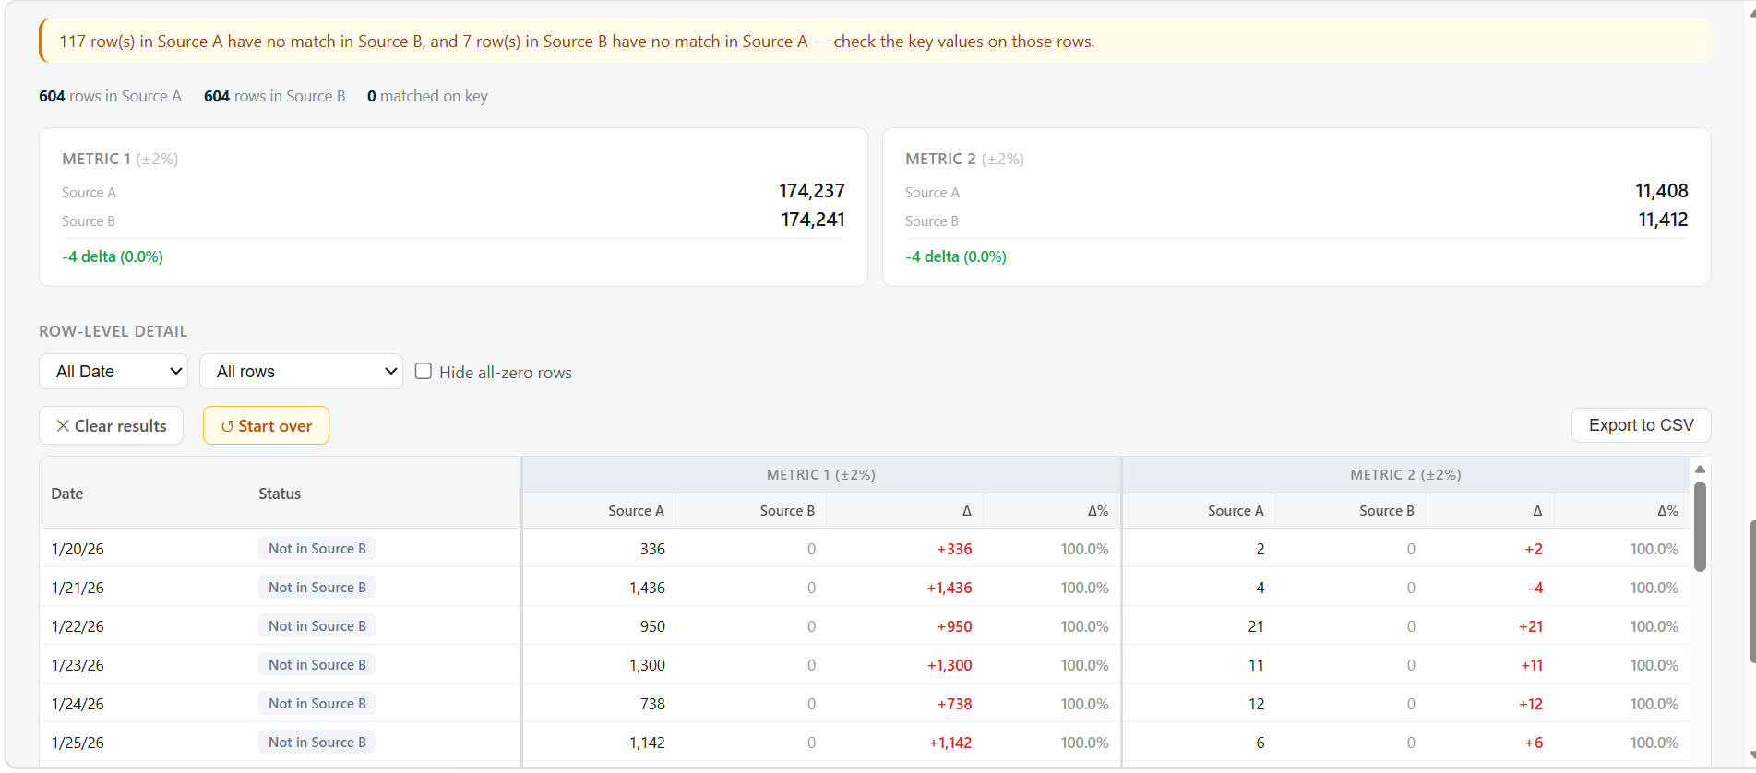

Out-of-Scope:
- Agent will not perform auto-correction or adjust original source files in any way; it is read-only
- Agent will compare data only on rows where match keys are identical
- Agent is limited to comparing existing data and will not create new metrics

Human In Loop:
- Agent is interactive and workflow is human-in-the-loop by design.
- Agent relies on human confirmation for different steps (e.g., files/tabs to parse, match keys to join, metrics to compare, thresholds to flag, file to use as baseline)
- Flag if there is an error reading a file/column and why

Acceptance Criteria:
- Successfully ingest and parse any valid Excel/CSV
- LLM-guided schema accurately identifies file column headers
- Output report correctly flags 100% of rows that do not pass user-defined thresholds
- Final report is correctly formatted and contains all columns specified (tbd)

